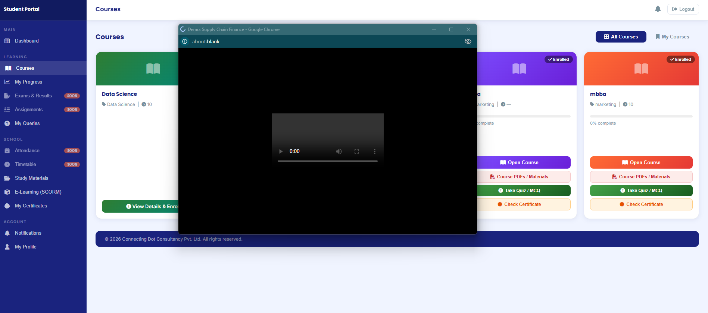
Video not starting.
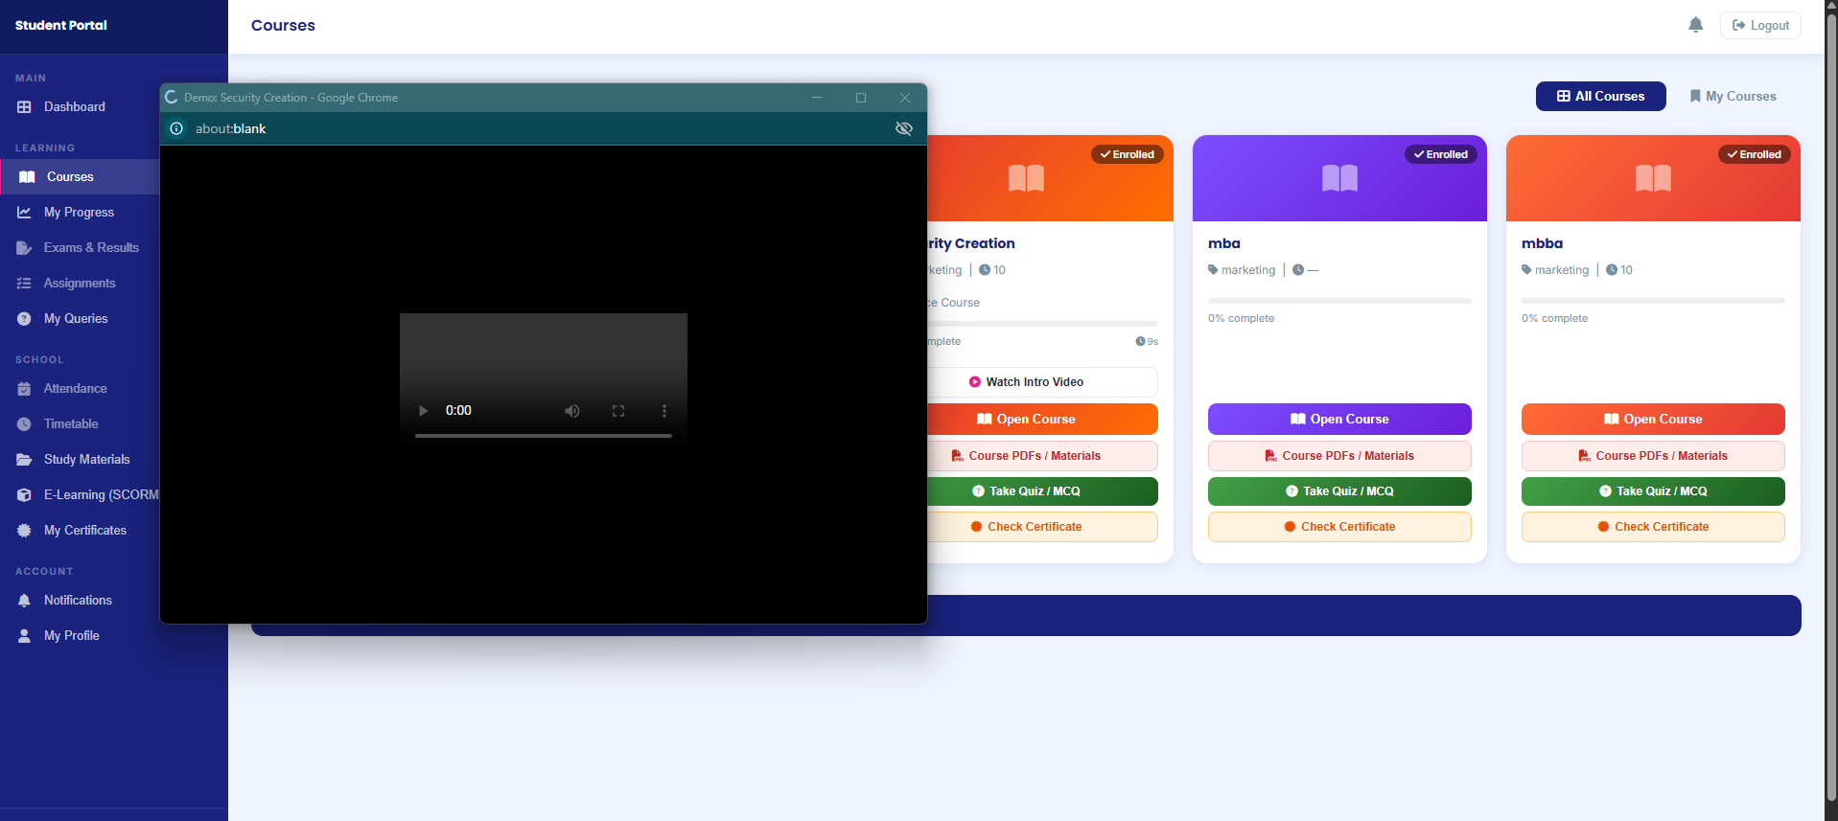
Video not starting.
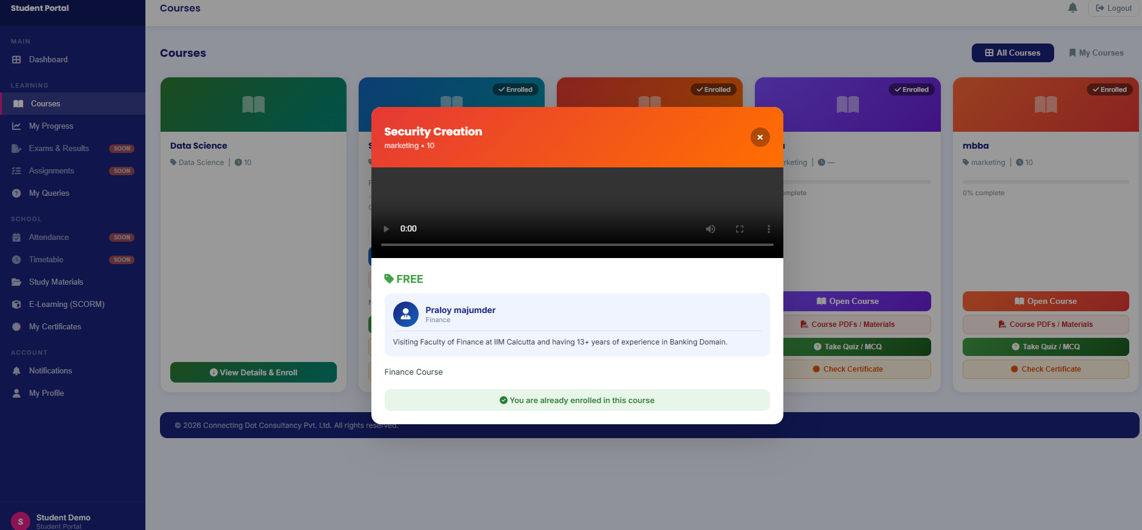
Video not starting.
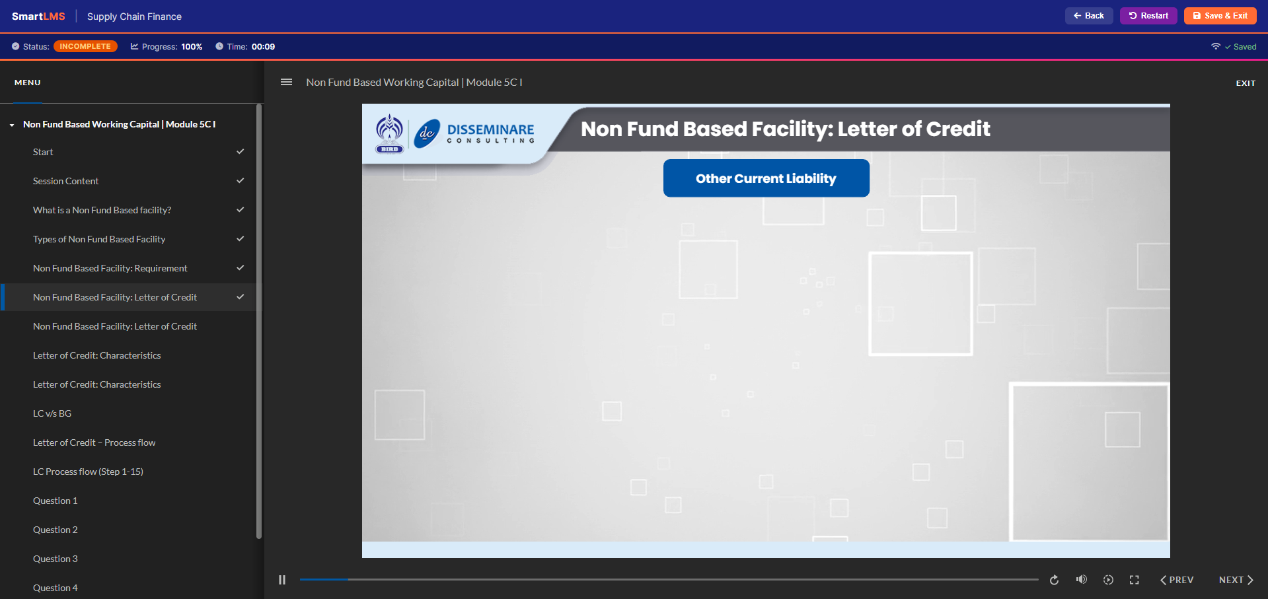
In Supply Chain Finance, Not Fund Based Module is showing up.

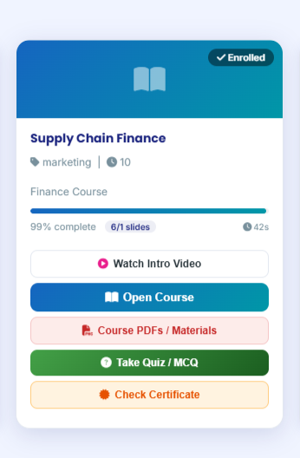
Completion and slide information is coming wrong.
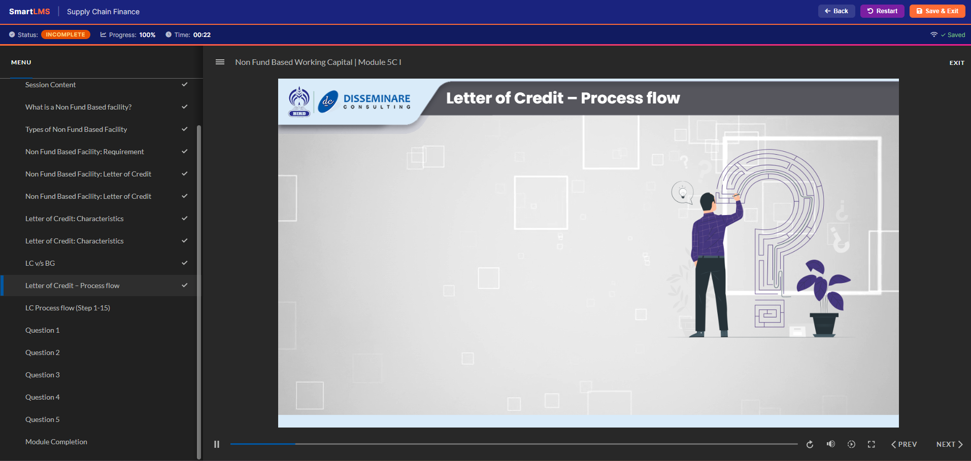
Progress information is incorrect, 100%
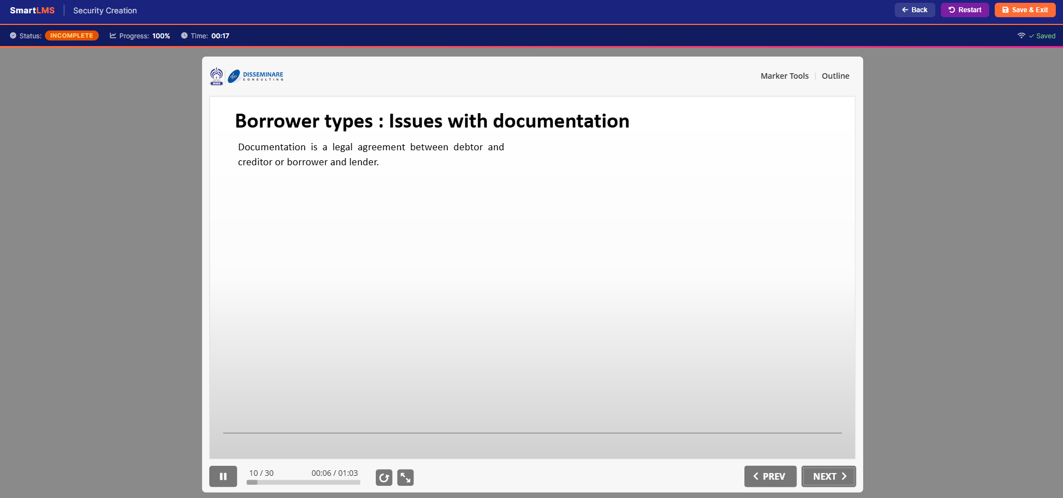
By slide 10, the completion is 100%. Not able to understand how the LMS is tracking the course progress.
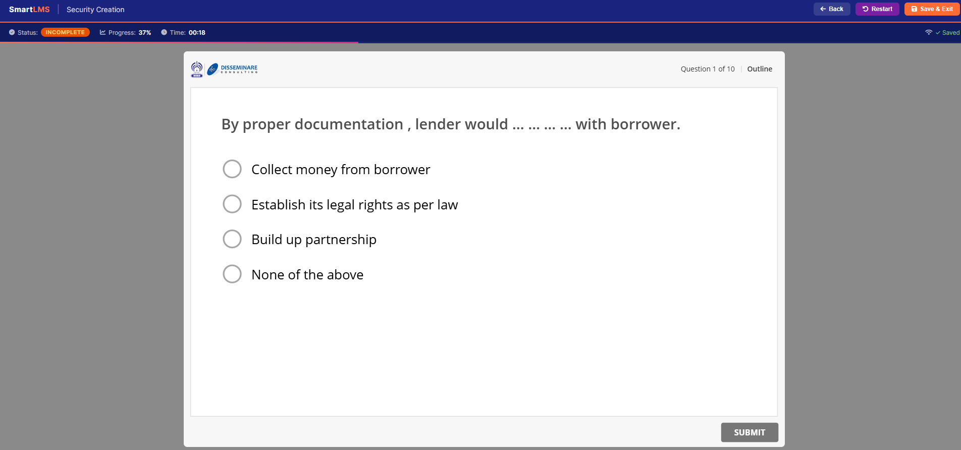
This time I have directly came to quiz part after slide 1. It is showing progress 37%. Then with time, the progress is increasing. See the next screenshot.
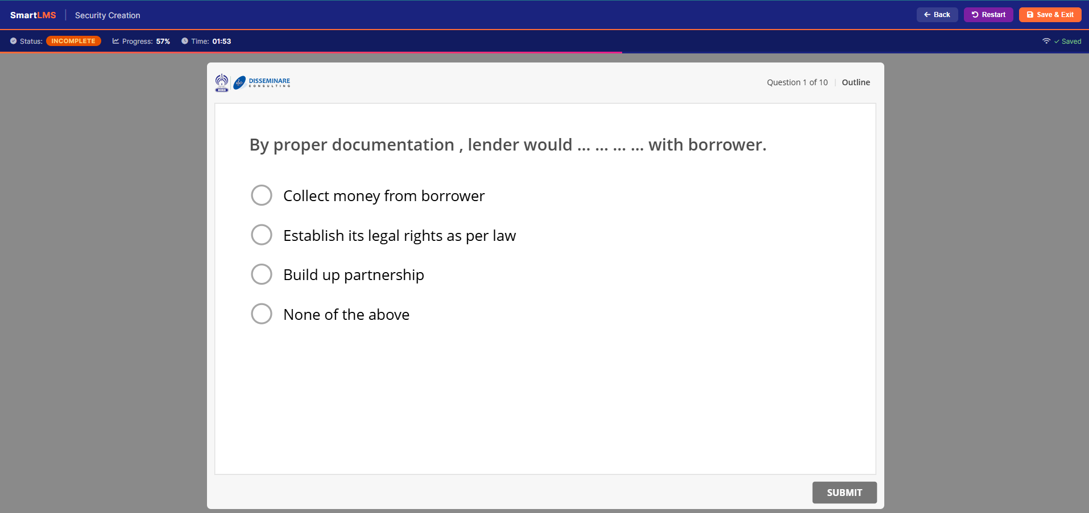
Now the progress is 57% however I haven’t selected/clicked anything.
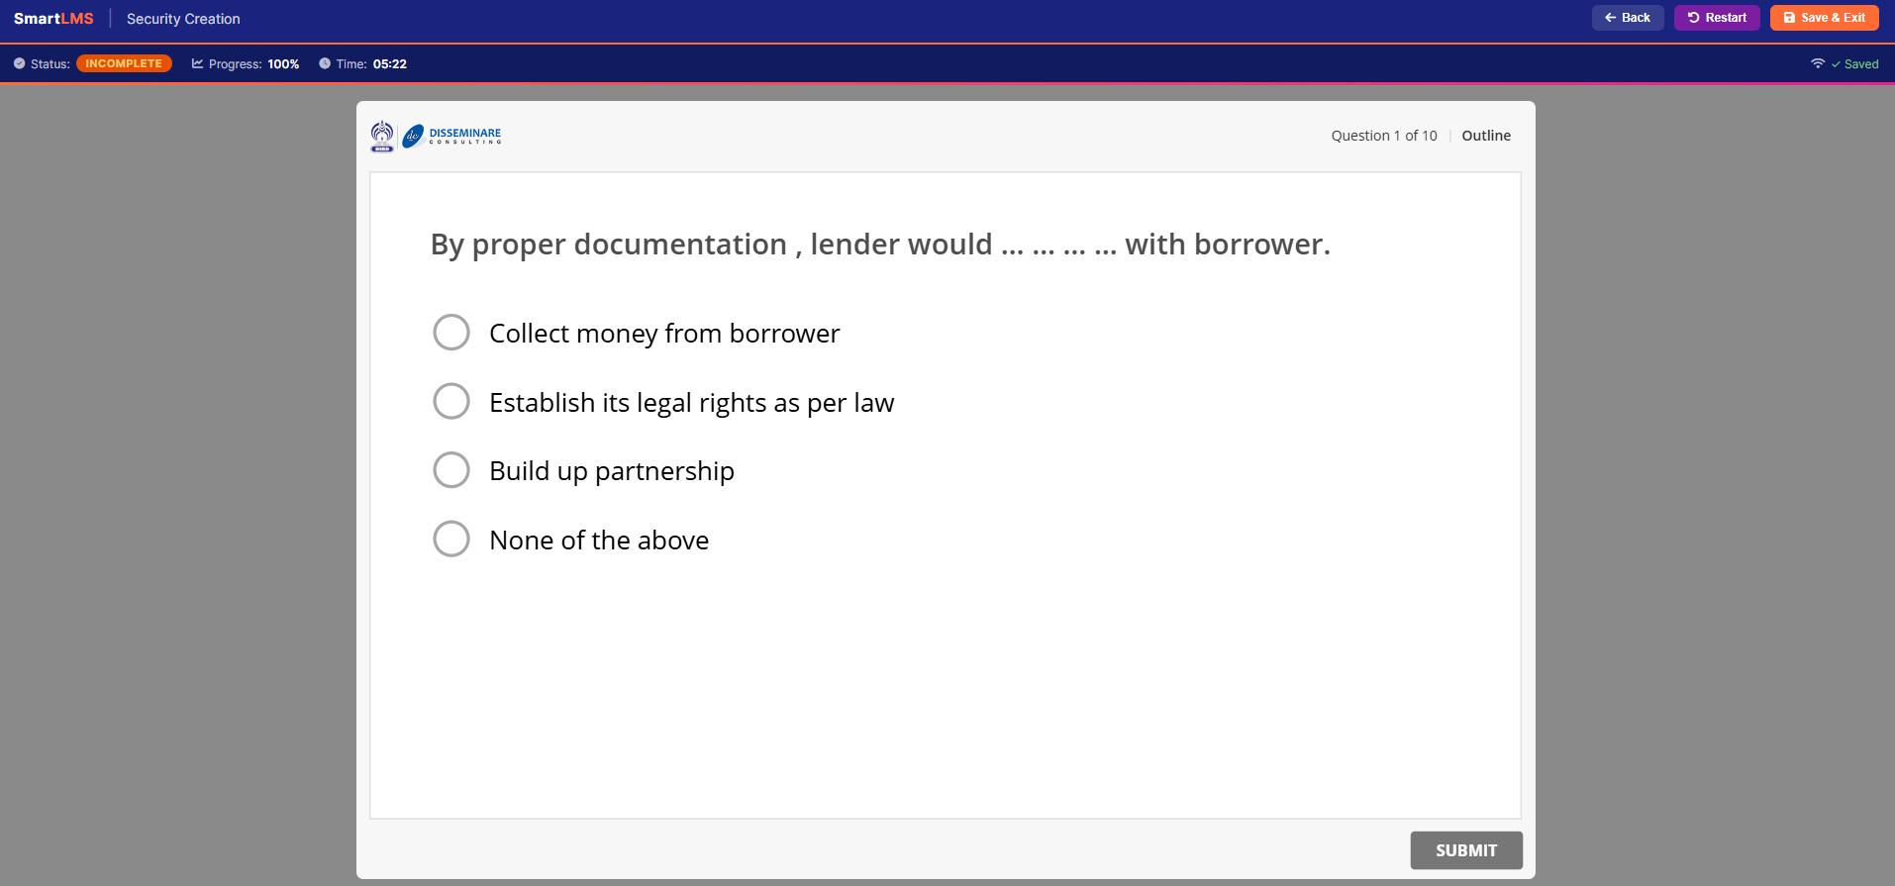
Now the progress is 100% automatically done. I just stayed idle in this slide.

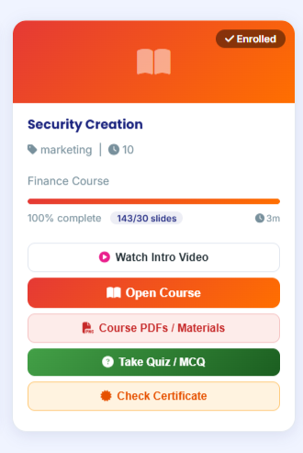
Completion and slide information is coming wrong.
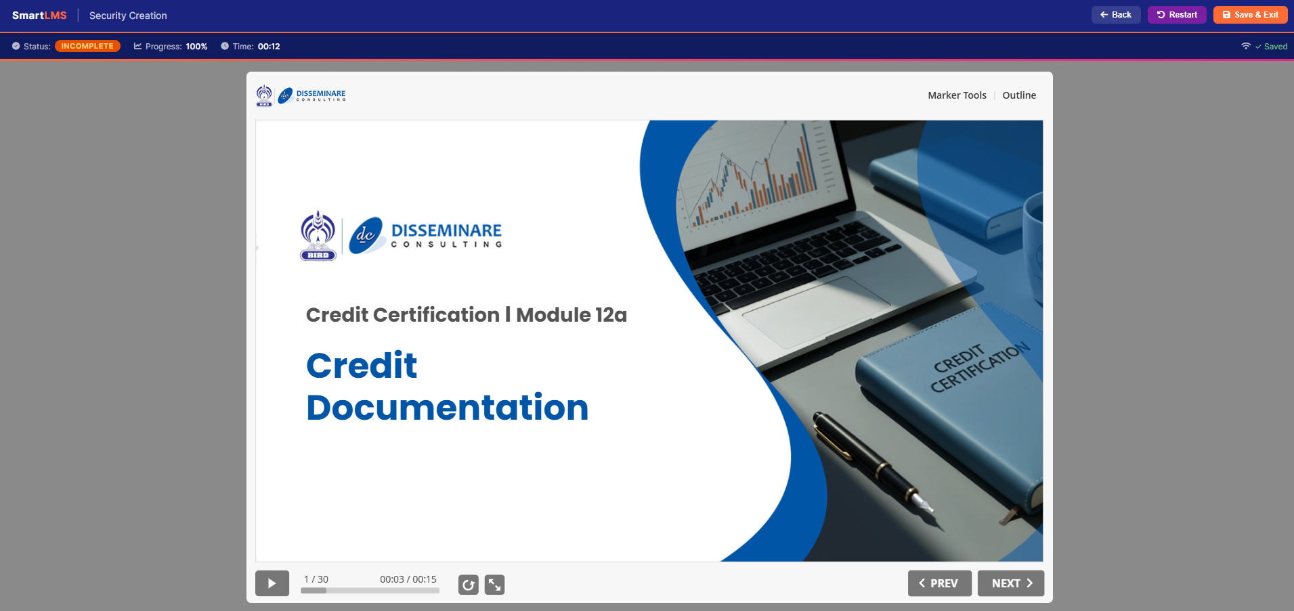
I have started the course again and not resumed, still showing 100%.
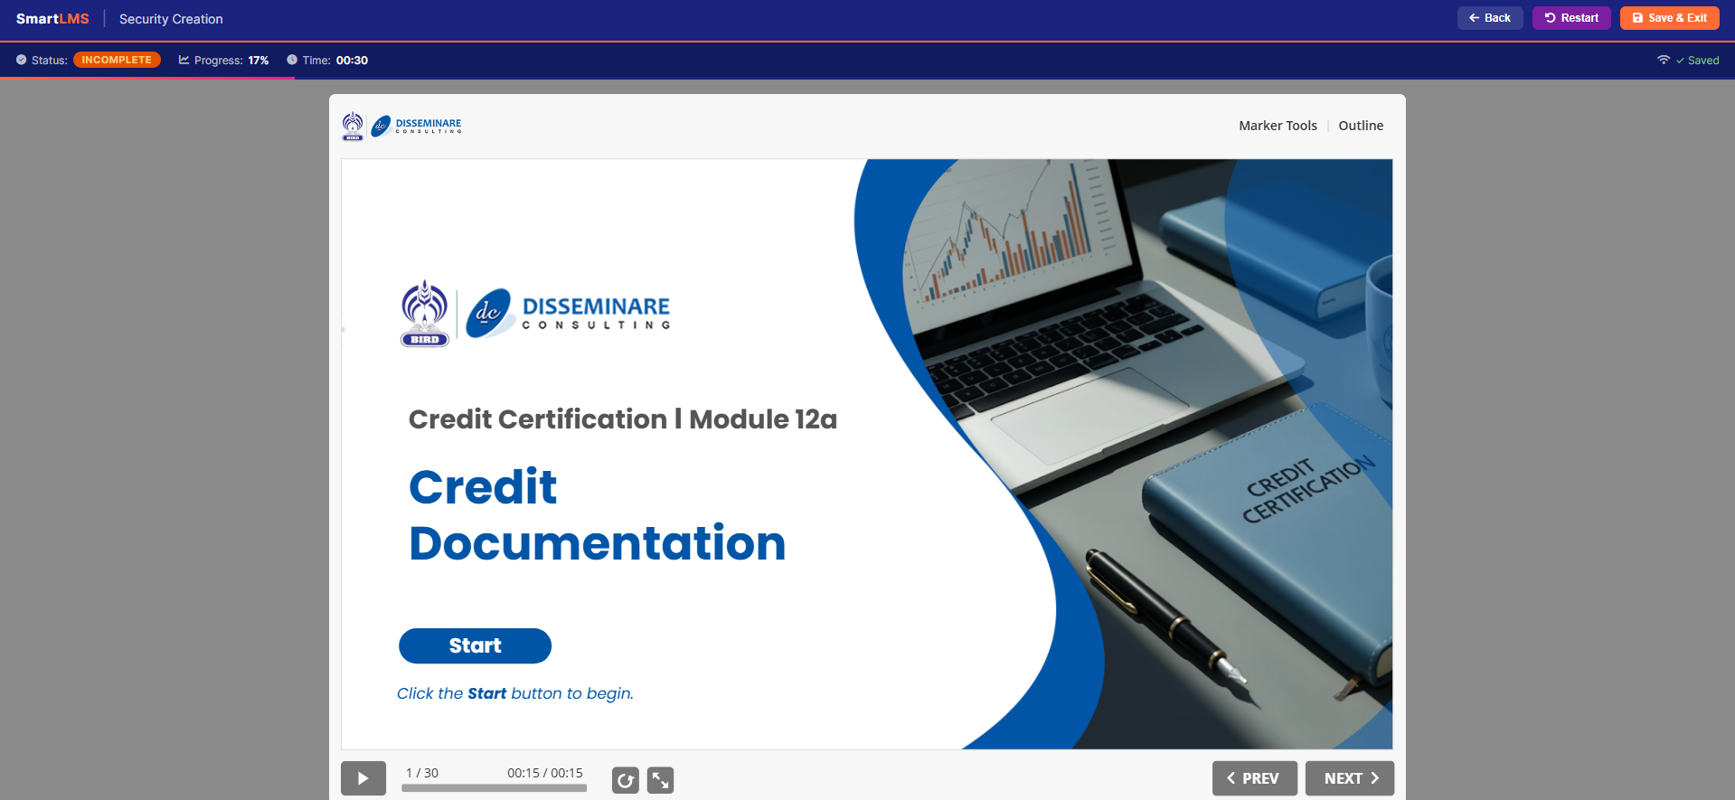
I have restarted the course, only stayed in slide 1, still the progress is ongoing. See next slide for better understanding.
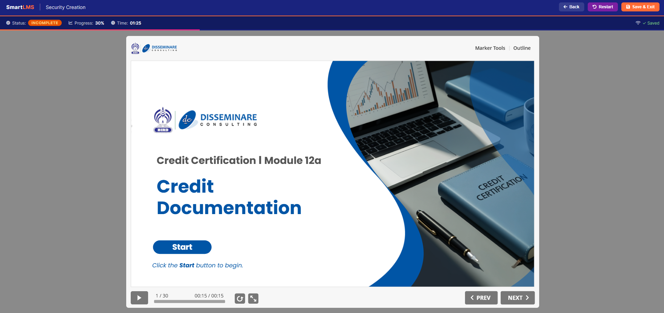
With time, the progress bar is automatically going up.
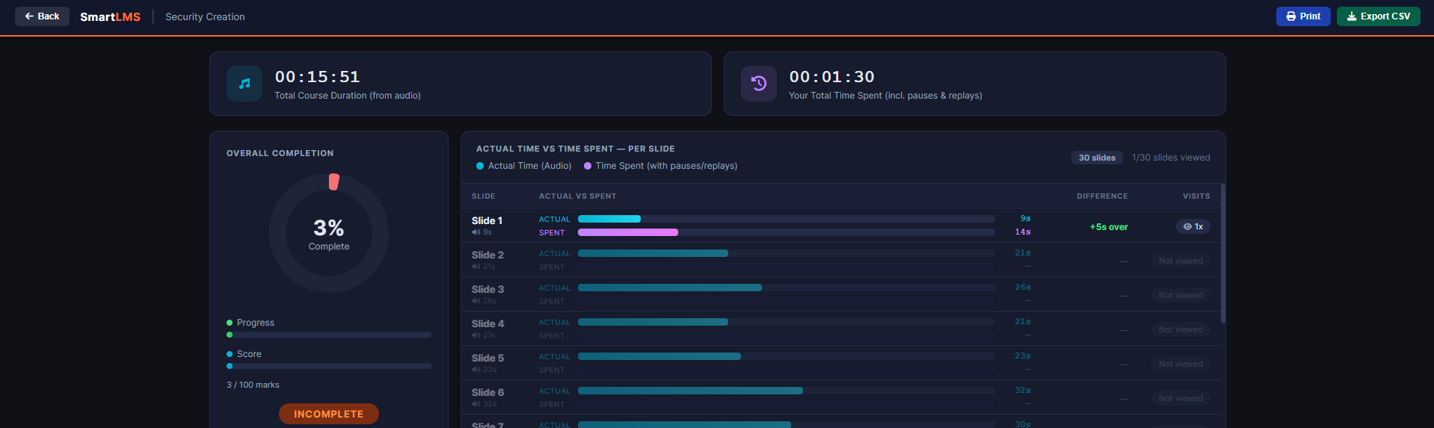
I have restarted the course security creation and stayed in slide 1 for 1min 30secs. Now when I see the analytics, the datas are not matching. Your Total Time Spent (incl. pauses & replays) this is correct, but the Slide 1 information is incorrect. Also here the progress is showing 3%, but when I am inside the course, it is showing 30%, as shown in the previous screenshot.
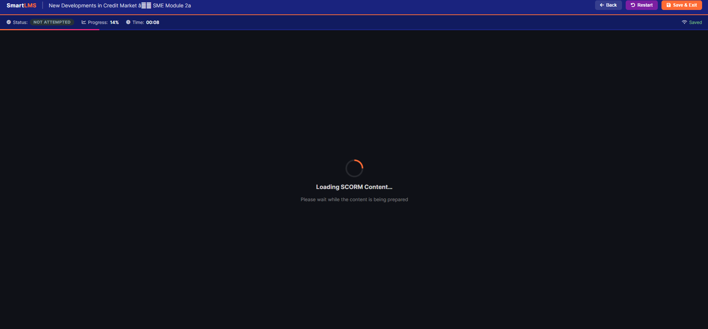
I left the course and started again, it is opening very delayed. Tried 2-3 times, same issue happed.
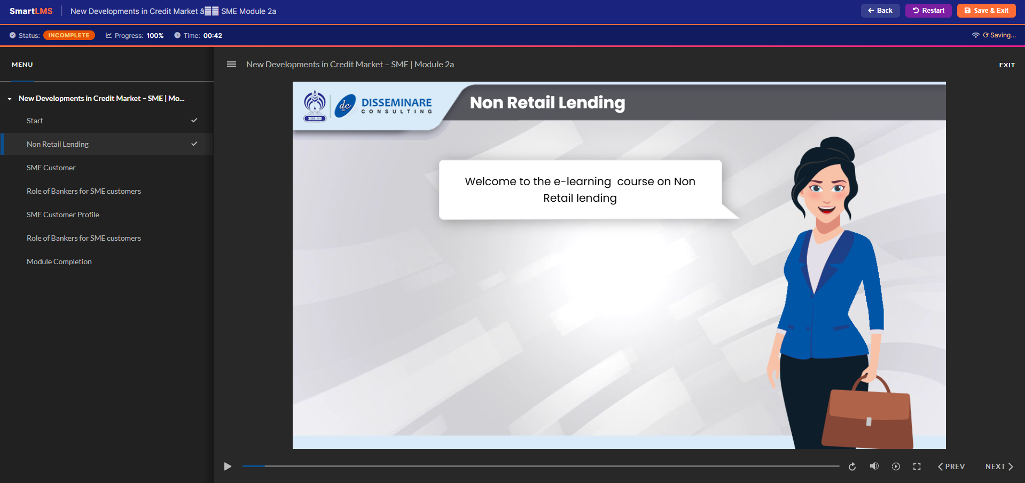
I just kept on clicking slide 1 & 2 alternatively and the progress marked upto 100%.

